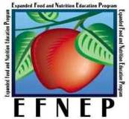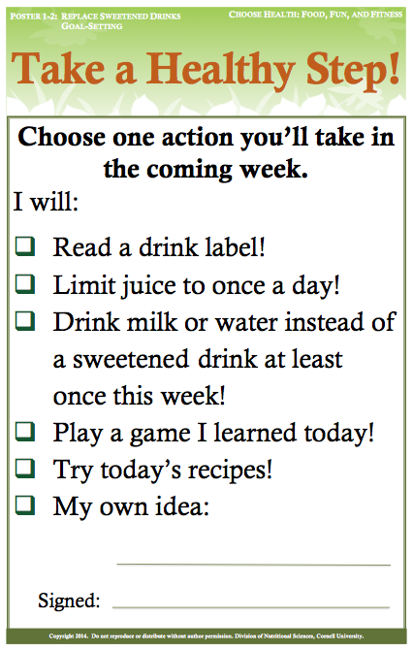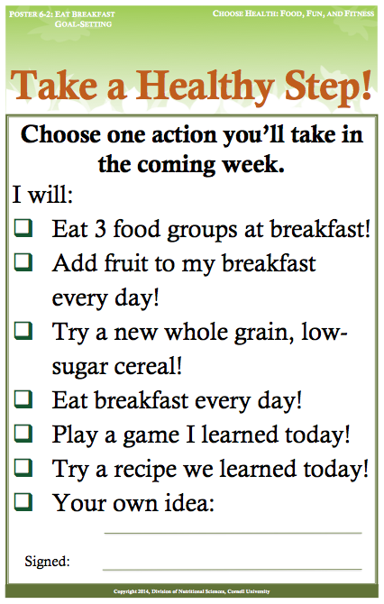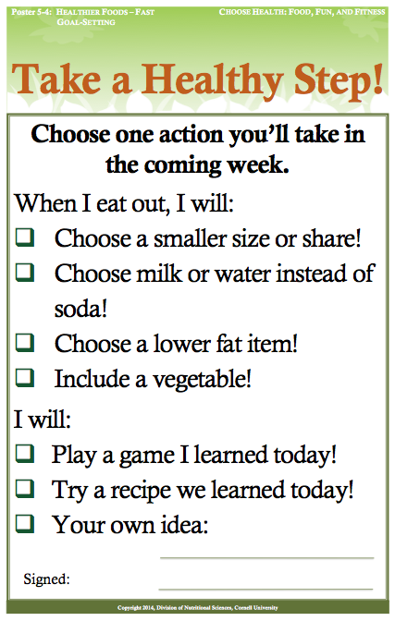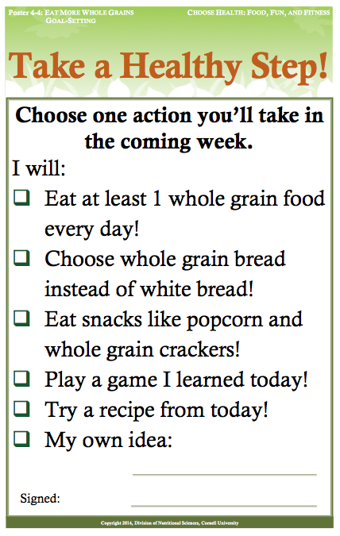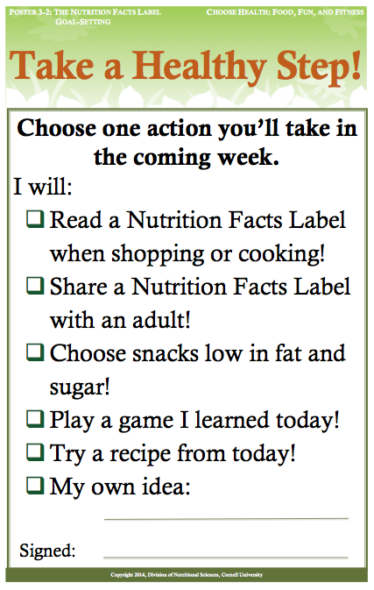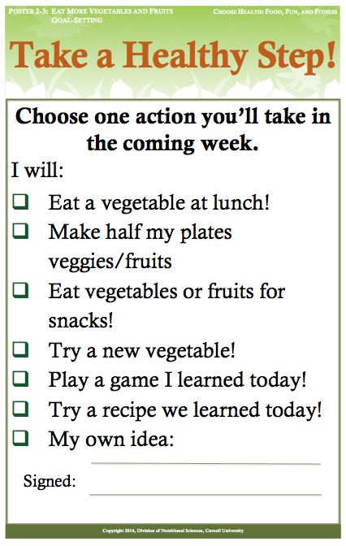

**Copyright 2011-15, Division of Nutritional Sciences, Cornell University. All Rights Reserved. Cornell Cooperative Extension is an equal opportunity provider and employer.**

**Choose Health: Food, Fun, and Fitness**

**Handout 6-3: CHFFF Celebration Certificate**

Choose Health: Food, Fun, and Fitness

Congratulates

For taking healthy steps to:

**Choose healthier foods when eating out!**

**Eat more**

**whole grains!**

**Read**

**Nutrition Facts Labels!**

**Color your plates with veggies & fruits!**

**Drink milk or water, not sweetened drinks!**

**Eat a healthy breakfast!**

***Your CHFFF Facilitators***